24.47: a) before:
after: 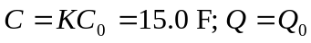
b) 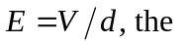same at all points between the plates (as long as far from the edges of the plates)
before:
after:

